

User Guide

Well Test interference Analysis

Table of Contents

Program Requirements 2

System Requirements 2

System Requirements 2

Supported platforms 2

Additional Notes 2

running the Program 3

App Usage 4

Features 4

data import 4

Smooth pressure 5

Trend pressure 6

App Options 7

chart visualization 10

# Program Requirements

Before installing the application, ensure your system meets the following requirements:

### System Requirements

* Operating System: Windows 10 or later.
* Processor: 1 gigahertz (GHz) or faster processor or System on a Chip (SoC)
* RAM: 1 gigabyte (GB) for 32-bit or 2 GB for 64-bit
* Hard Disk Space: Minimum 50 MB of available hard disk space

### System Requirements

* .NET Runtime: .NET 8 runtime or later. If not already installed, it can be downloaded from the official .NET website.
* Microsoft Visual C++ Redistributable: Required for some dependencies. It can be downloaded from the official Microsoft website.

### Supported platforms

* The application is designed to run on Windows-based systems only.
* Compatibility with other operating systems or platforms is not guaranteed.

### Additional Notes

* **Permissions:** Administrator privileges might be required to install the application successfully.
* **Firewall/Antivirus:** Ensure that your firewall or antivirus software does not block the installation process.

# running the Program

* Unzip the archive
* Open the app folder
* Double-click on the executable file.

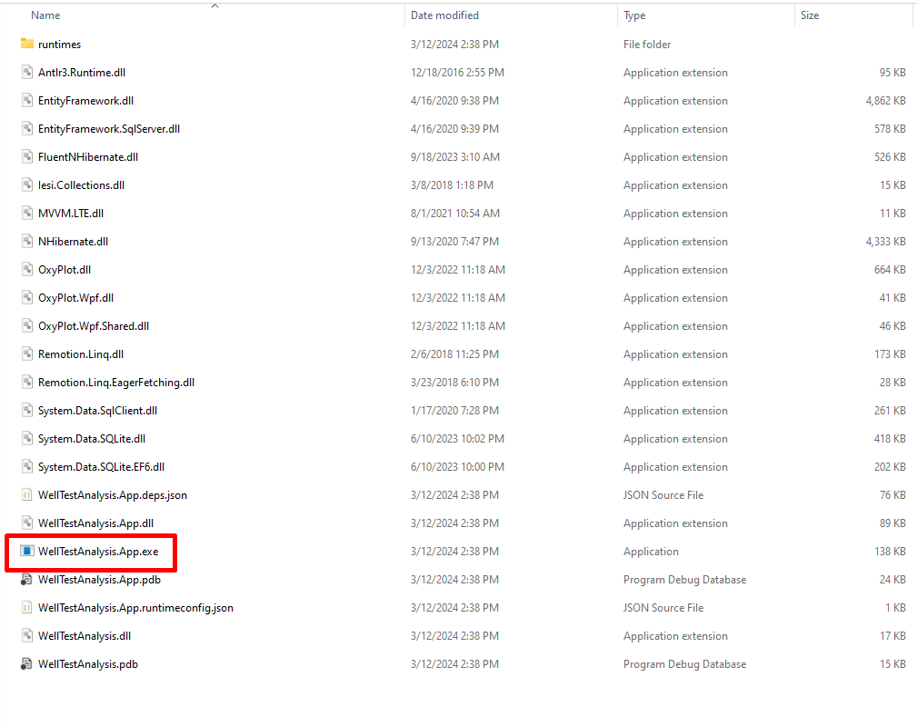

Fig. 1. App executable file.

# App Usage

## Features

The app comprises of 3 features for data entry, analysis and visualization

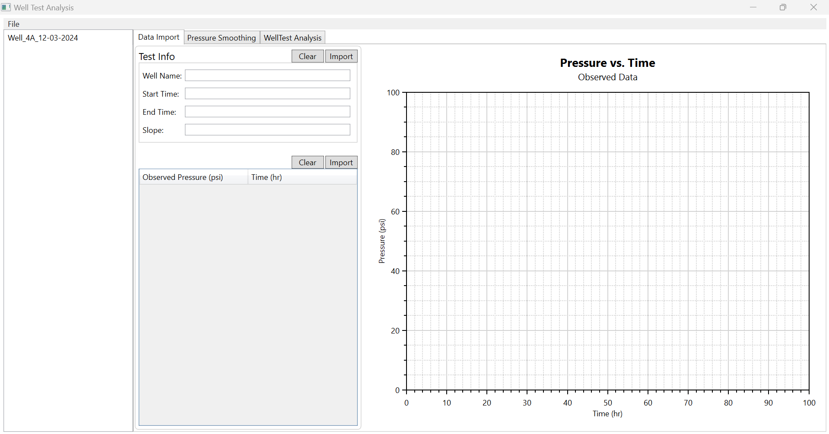

Fig. 2. App features

### data import

This feature allows user to import or enter well test information and observed pressure data.

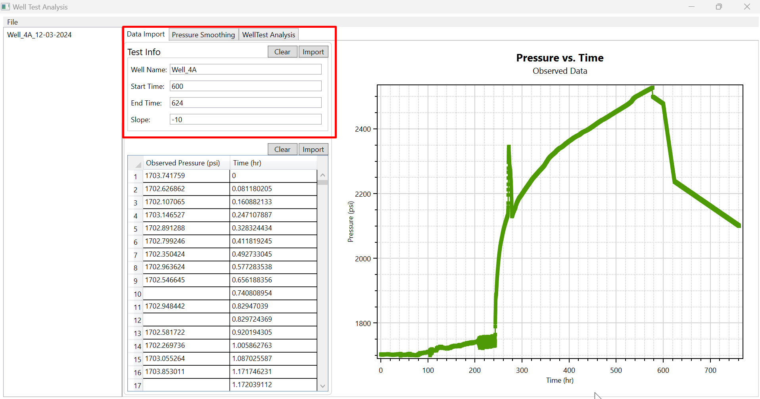

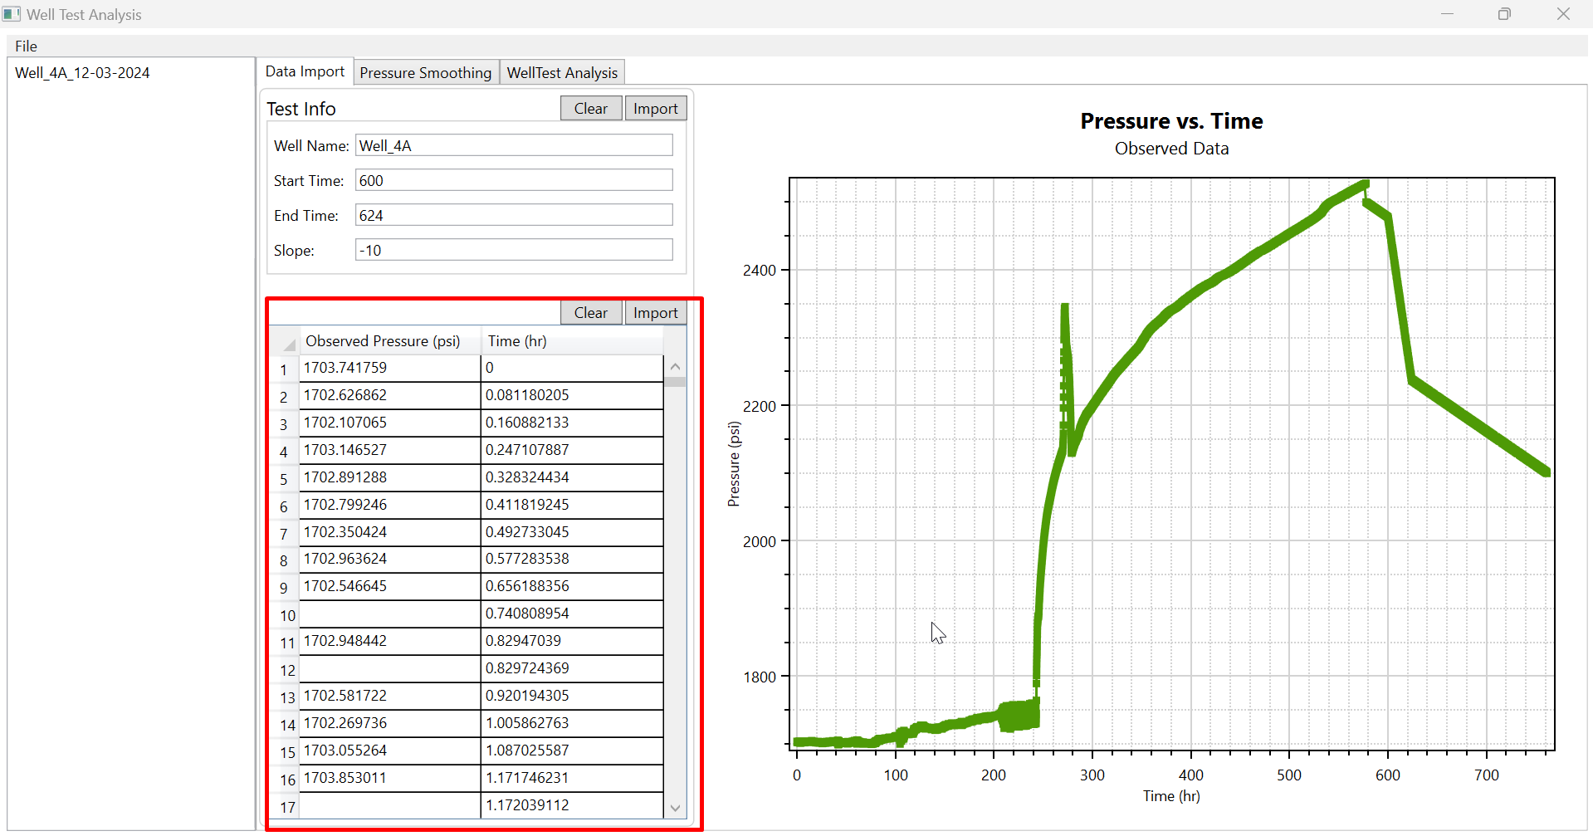

Fig. 3. Test Info

### Smooth pressure

This feature provide option to smoothen the observed pressure.

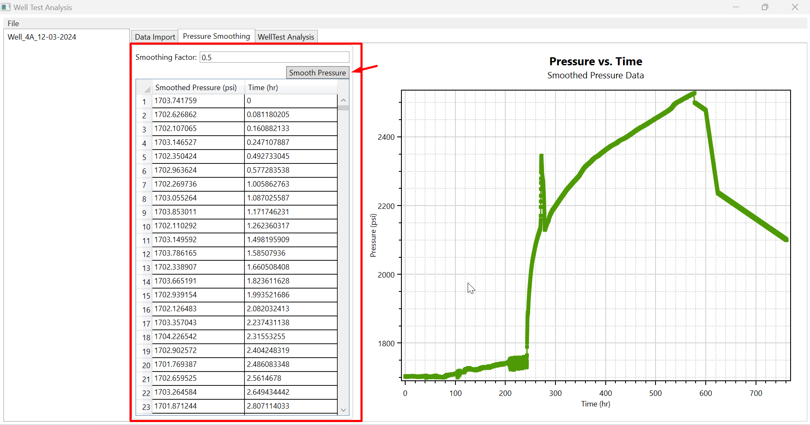

Fig. 4. Smooth Pressure

### Trend pressure

This feature provide option to calculate linear trend of the smoothen pressure vs time series between a given time range (Start and End time of test).

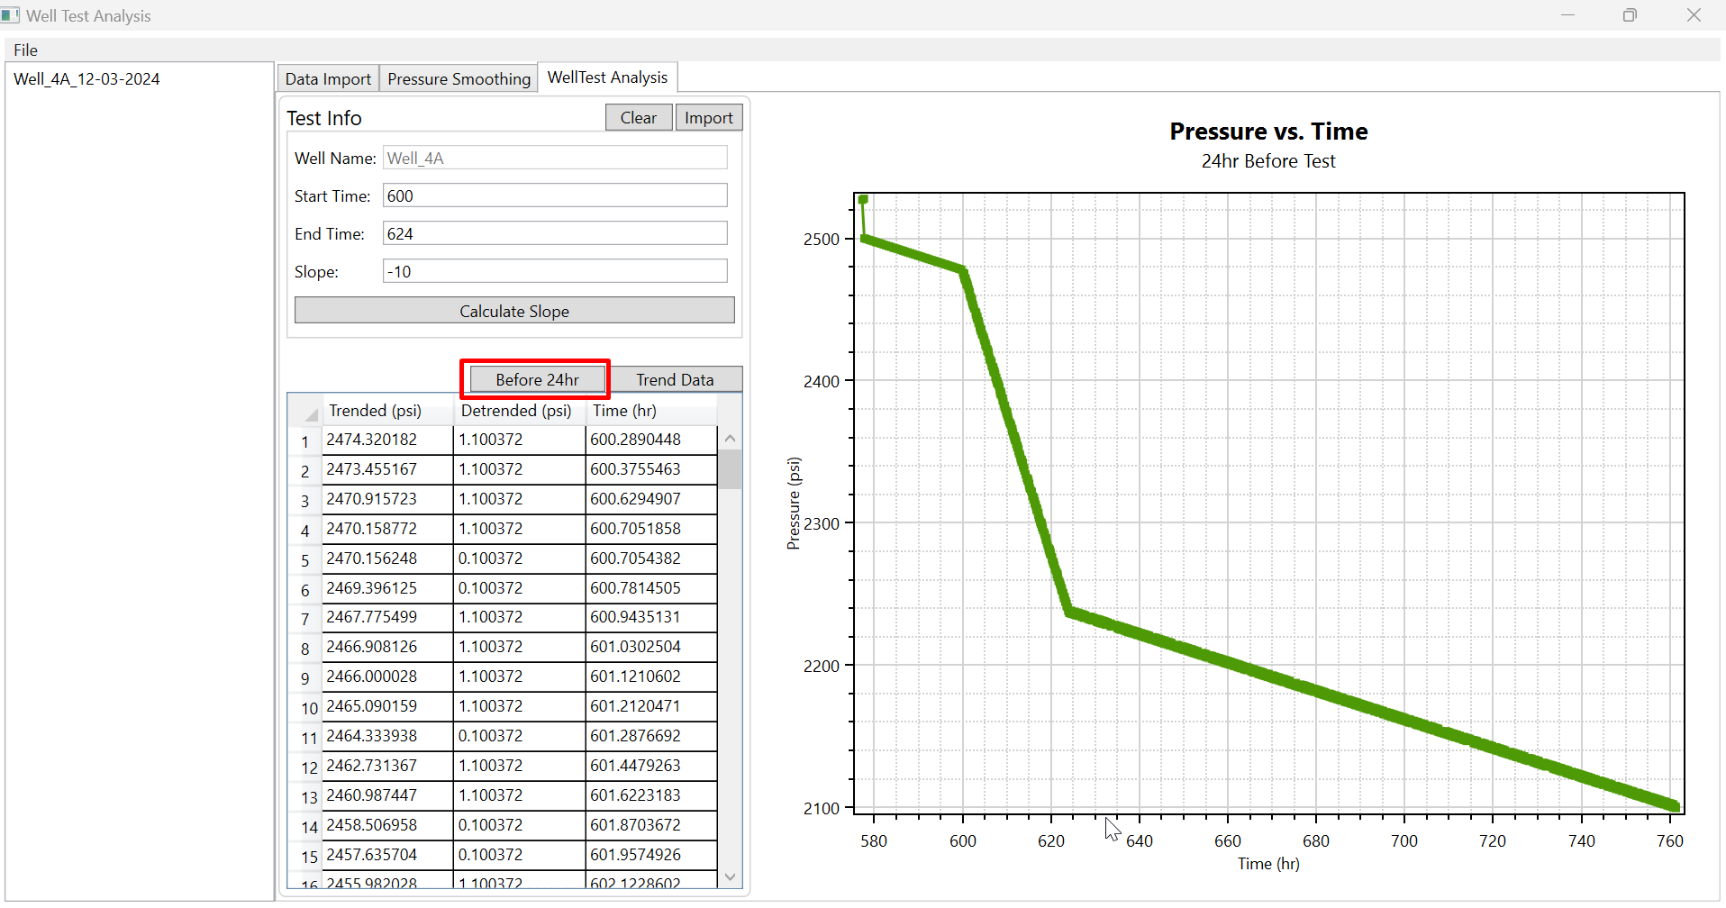

Fig. 5. Pressure vs Time 24 hours before test

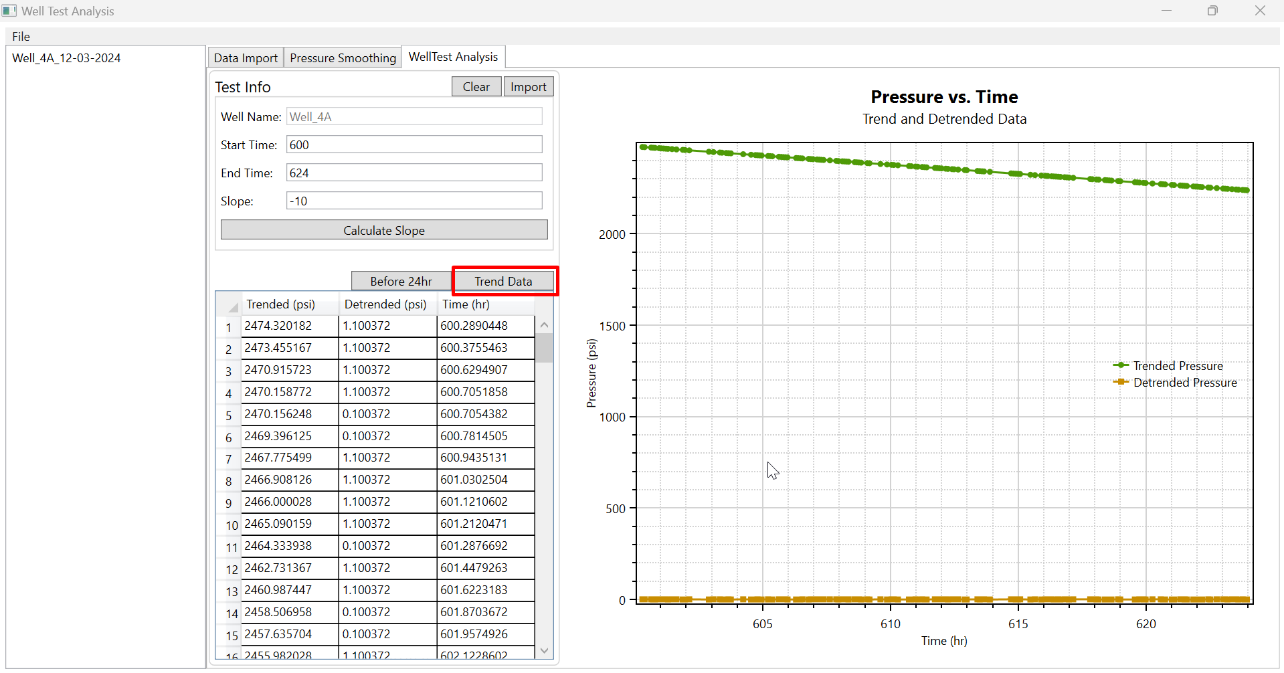

Fig. 6. Linear Trend and Detrended Data

### App Options

This comprises of features that allow the user to create a new analysis, import previous analysis, export analysis results, save the results to the database and exit the application.

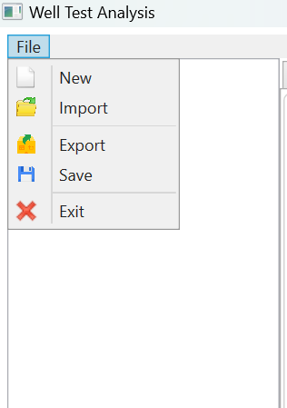

Fig. 7. App Options

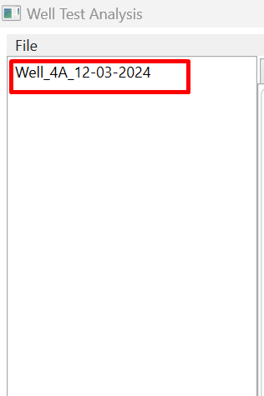

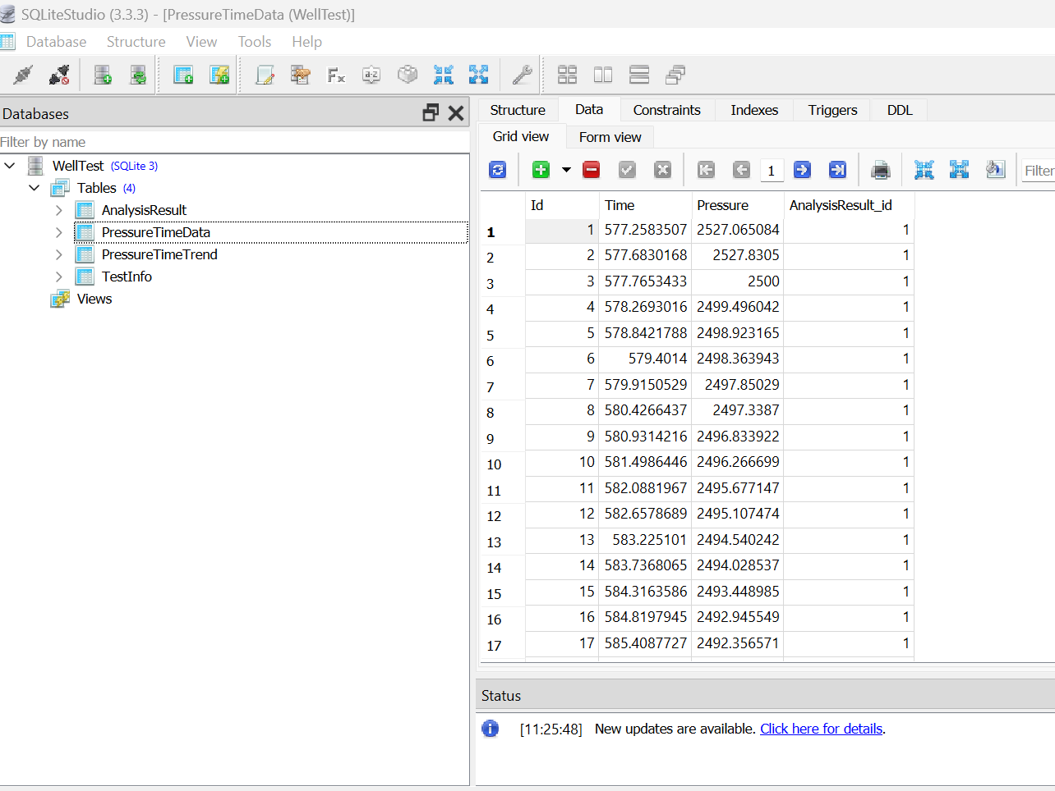

Fig. 8. SQLite Database

### chart visualization

This feature allows user to visualize data in a graphical format:

* Observed Data
* Smoothen Data
* Trended Data
* Detrended Data

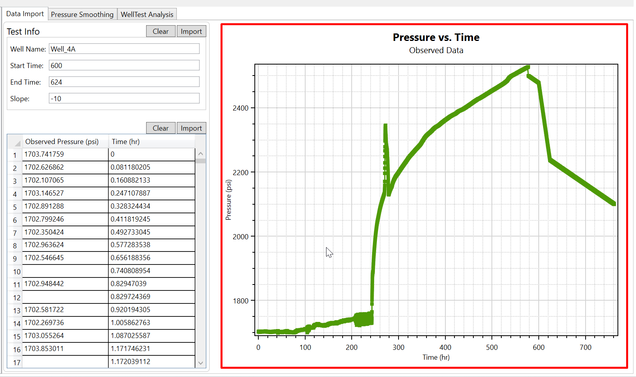

Fig. 9. Observed Pressure Chart

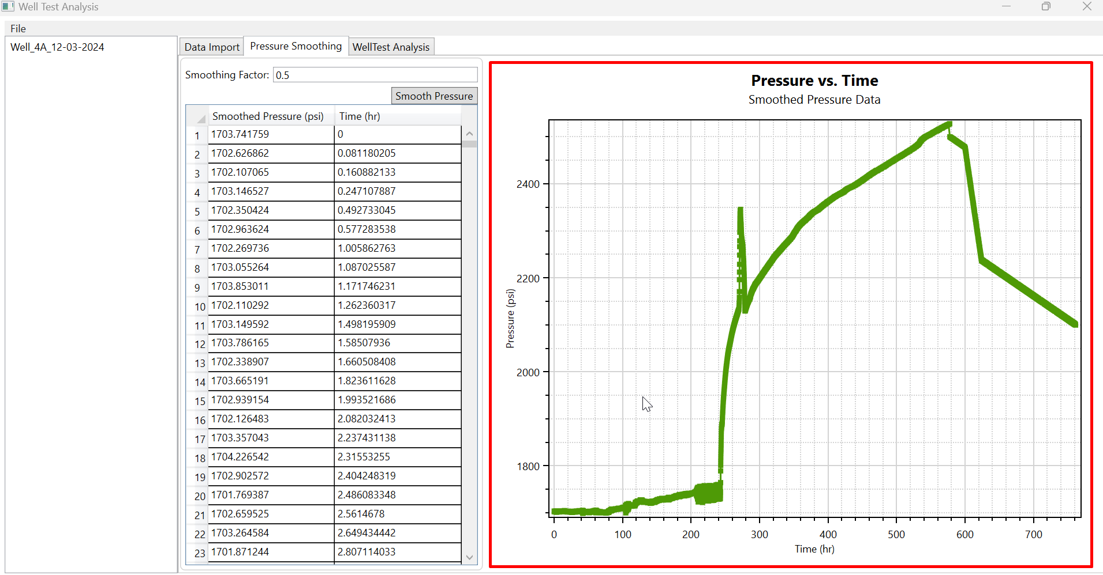

Fig. 10. Smoothen Pressure Data

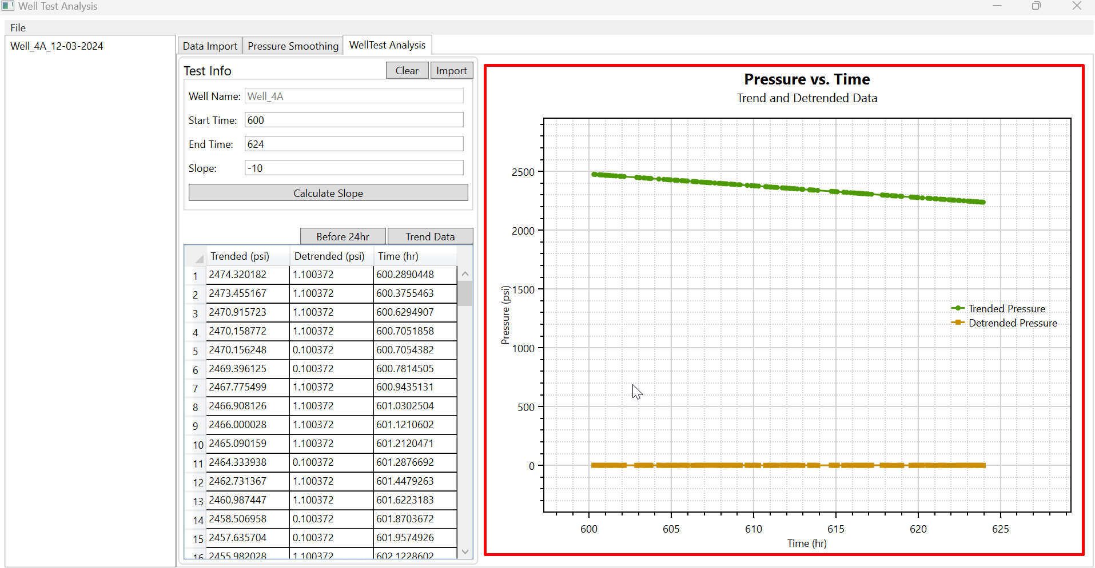

Fig. 11. Trended and Detrended Data